LAB ACTIVITY 1F: RELATIVE LAYOUT, OPERATOR

Learning outcomes:

By the end of this tutorial session, you should be able to:
- Traversing an android application structure
- Outline the component of android application
- Use android tool repository

A. New Project
- Create New Project > Empty Views Activity > name it as, “Discount Calculator”.
- Select Language: Java and click Finish.
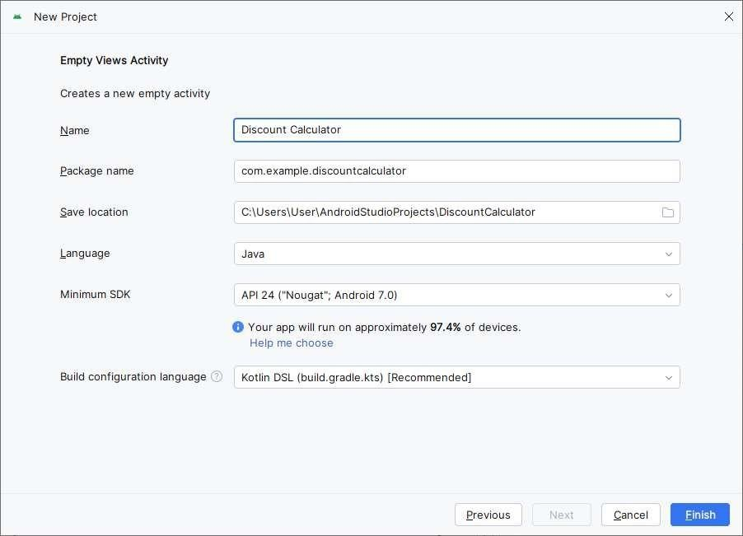

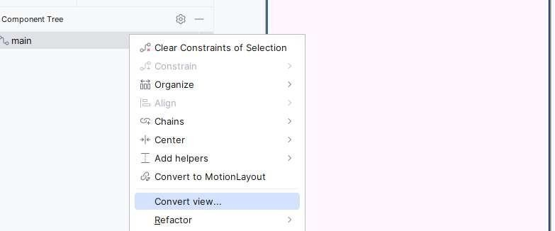
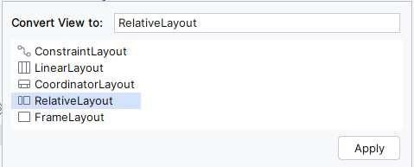
- Convert Constraint Layout to Relative Layout.

- Add TextView as below information.
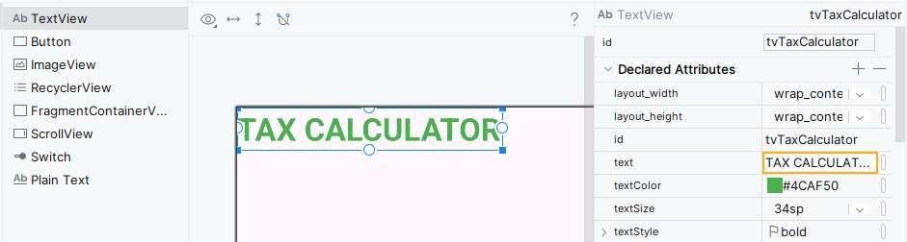

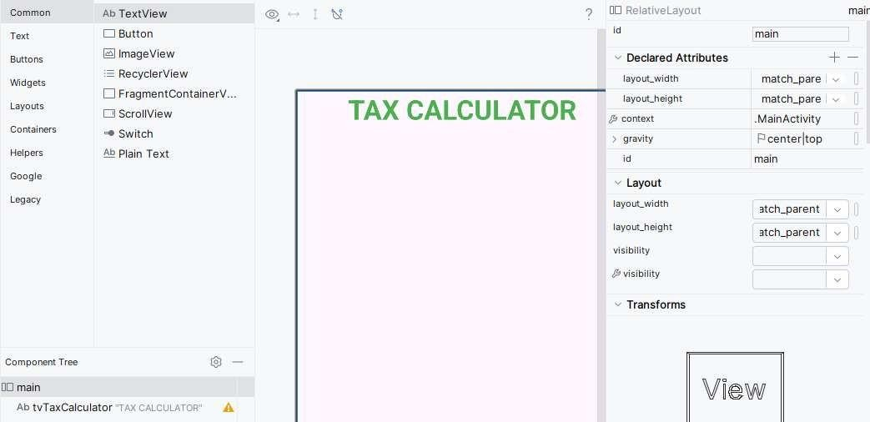
- Set Gravity: Center | Top for Relative Layout.

- Add TextView.
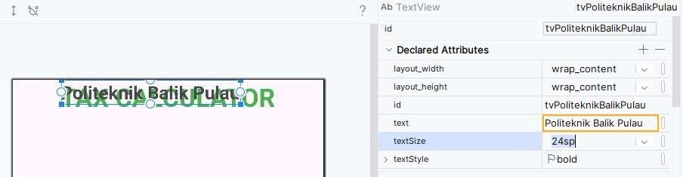

- Set tvPoliteknikBalikPulau to stay below tvTaxCalculator.
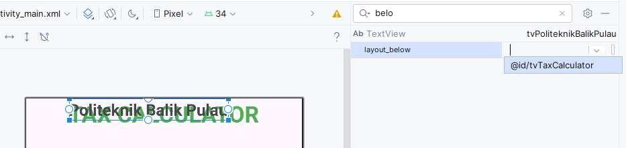
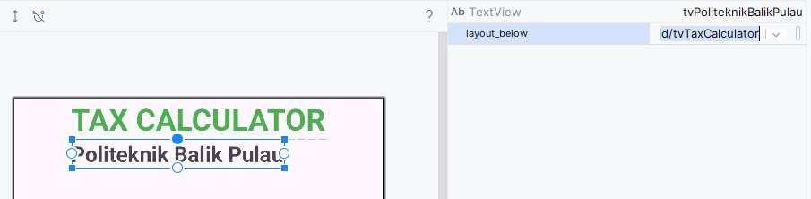

- Press CTRL + click both of TextViews. Set Layout Center Horizontal: True.
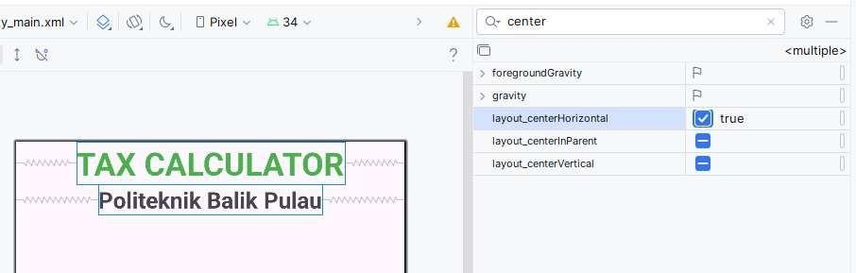

- Add TextView.
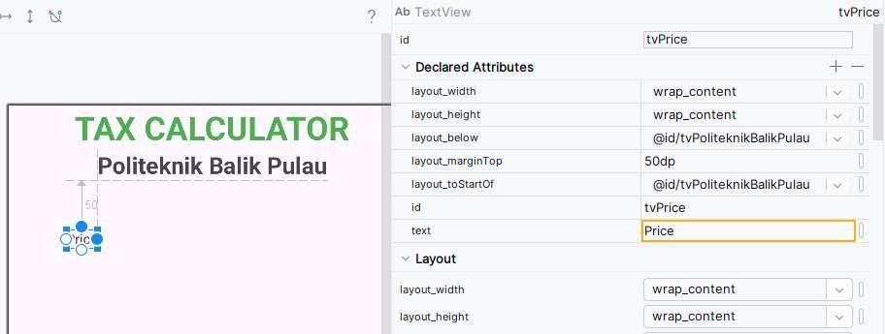

- Add EditText.
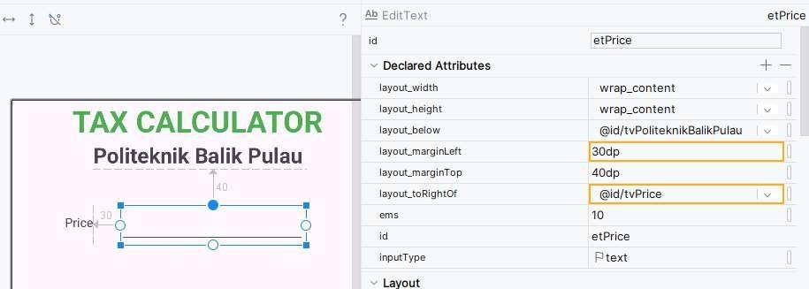

- Add TextView.
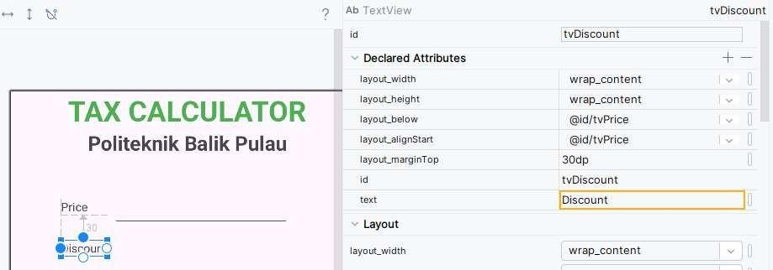

- Add EditText.
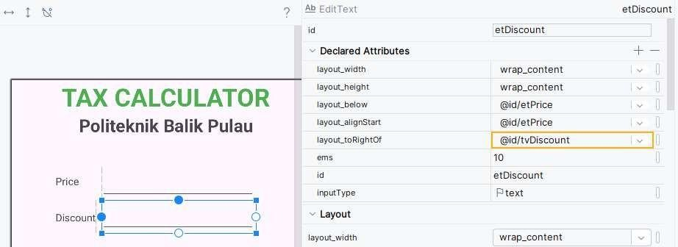

- Add TextView.
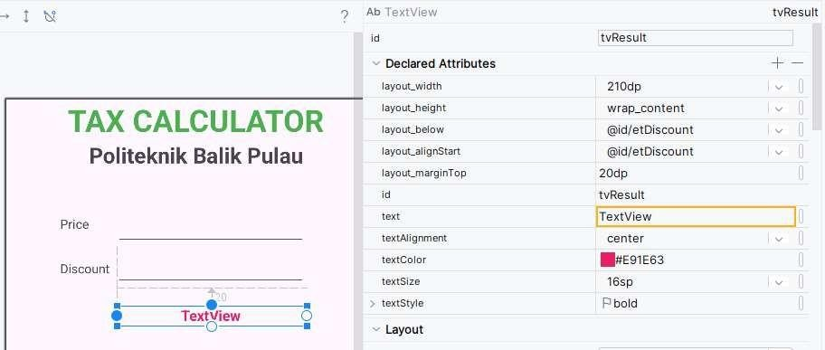

- Turn Orientation Phone to Landscape.
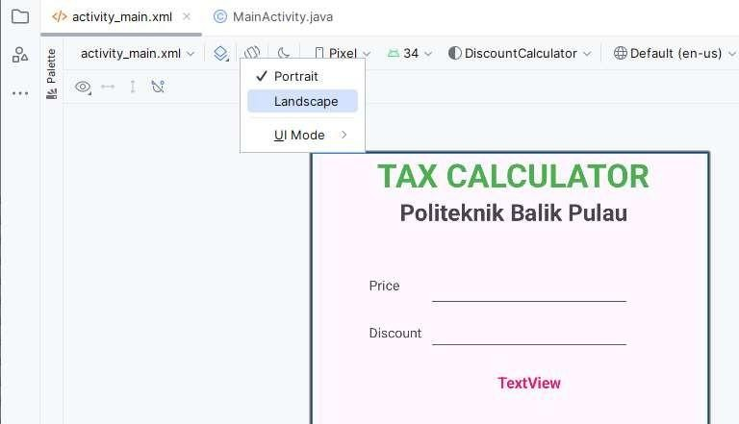
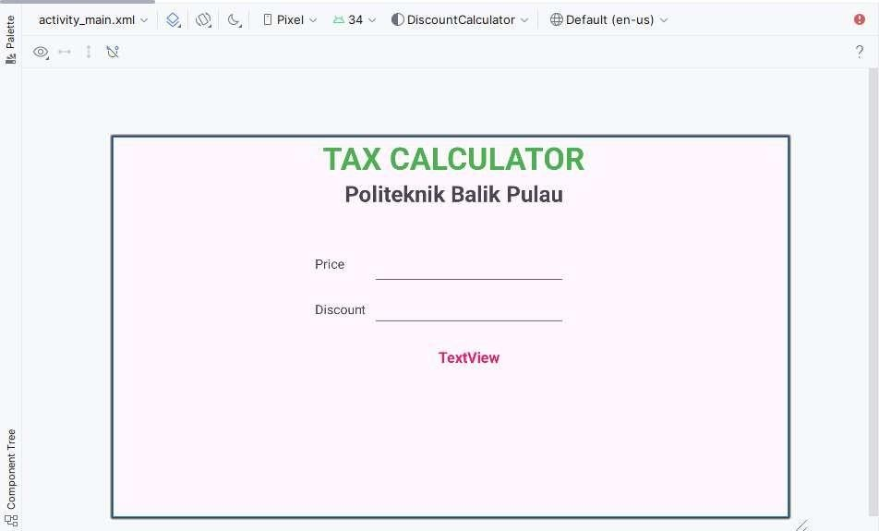

Layout does not mess and still follow the arrangement.

- If the Title: Tax Calculator look too close to top of Constraint Layout, you can change it margin for example:
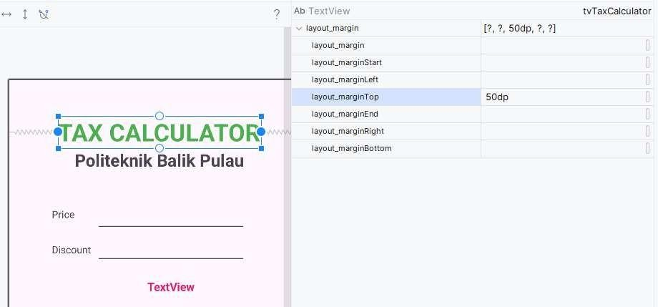

- Add Button.
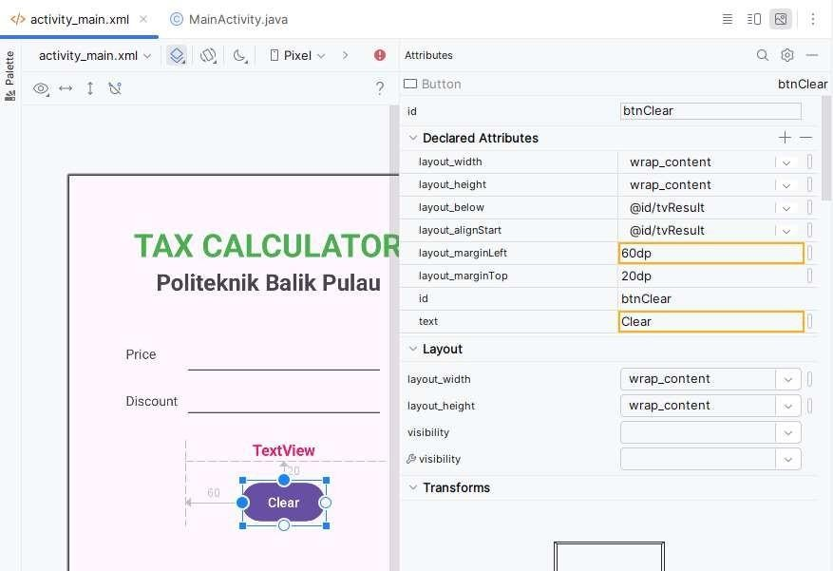

- Missing Discount in Percent (%). Add TextView as backup.
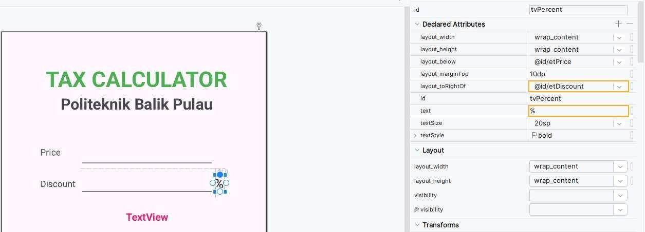

- Insert this code to the MainActivity.java.
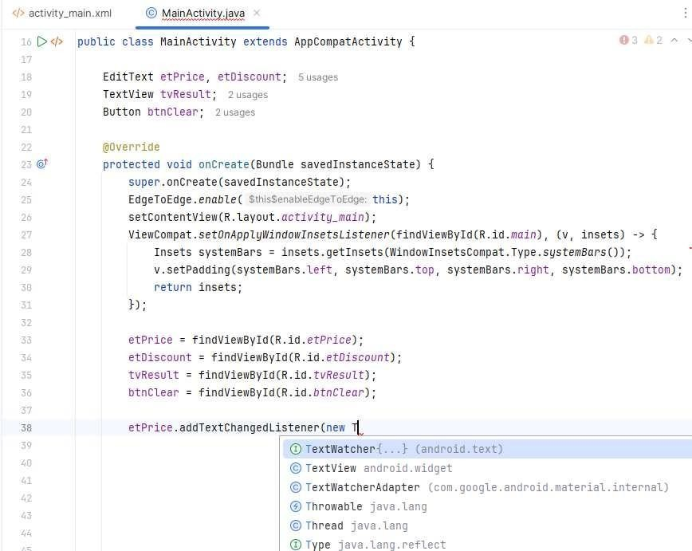

After select TextWatcher, auto code will generate.
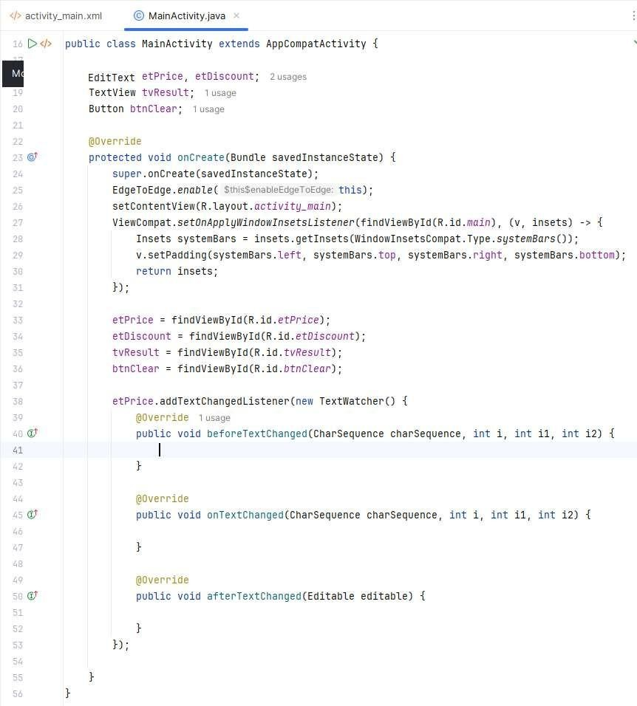


Full coding on MainActivity.java:
public class MainActivity extends AppCompatActivity {

EditText etPrice, etDiscount; TextView tvResult;
Button btnClear;

@Override
protected void onCreate(Bundle savedInstanceState) { super.onCreate(savedInstanceState); EdgeToEdge.enable(this); setContentView(R.layout.activity_main);
ViewCompat.setOnApplyWindowInsetsListener(findViewById(R.id.main), (v, insets) -> { Insets systemBars = insets.getInsets(WindowInsetsCompat.Type.systemBars()); v.setPadding(systemBars.left, systemBars.top, systemBars.right,
systemBars.bottom);
return insets;
});
etPrice = findViewById(R.id.etPrice); etDiscount = findViewById(R.id.etDiscount); tvResult = findViewById(R.id.tvResult); btnClear = findViewById(R.id.btnClear);

etPrice.addTextChangedListener(new TextWatcher() { @Override
public void beforeTextChanged(CharSequence charSequence, int i, int i1, int i2)
{
}

@Override
public void onTextChanged(CharSequence charSequence, int i, int i1, int i2) {
}

@Override
public void afterTextChanged(Editable editable) {

double price, discount; double new_price;
if(etPrice.getText().toString().isEmpty())
{
price = 0;
}
else {
price = Double.parseDouble(etPrice.getText().toString());
}

if(etDiscount.getText().toString().isEmpty())
{
discount = 0;
}
else {
discount = Double.parseDouble(etDiscount.getText().toString());
}

new_price = price - (price * discount/100); tvResult.setText(String.format("RM%.2f", new_price));

}
});

etDiscount.addTextChangedListener(new TextWatcher() { @Override
public void beforeTextChanged(CharSequence charSequence, int i, int i1, int i2)
{

}

@Override
public void onTextChanged(CharSequence charSequence, int i, int i1, int i2) {
}

@Override
public void afterTextChanged(Editable editable) {

double price, discount; double new_price;

if(etPrice.getText().toString().isEmpty())
{
price = 0;
}
else {
price = Double.parseDouble(etPrice.getText().toString());
}
if(etDiscount.getText().toString().isEmpty())
{
discount = 0;
}
else {
discount = Double.parseDouble(etDiscount.getText().toString());
}

new_price = price - (price * discount/100); tvResult.setText(String.format("RM%.2f", new_price));

}
});

btnClear.setOnClickListener(view -> { etPrice.setText(""); etDiscount.setText(""); etPrice.requestFocus();
});

}
}

- Run app and test.
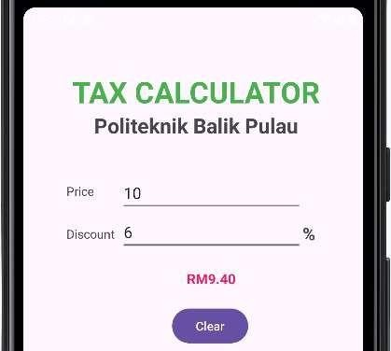

Report Lab Activity 1F SHARAVANAN A/L ARUCHIANAN
21DDT23F1398

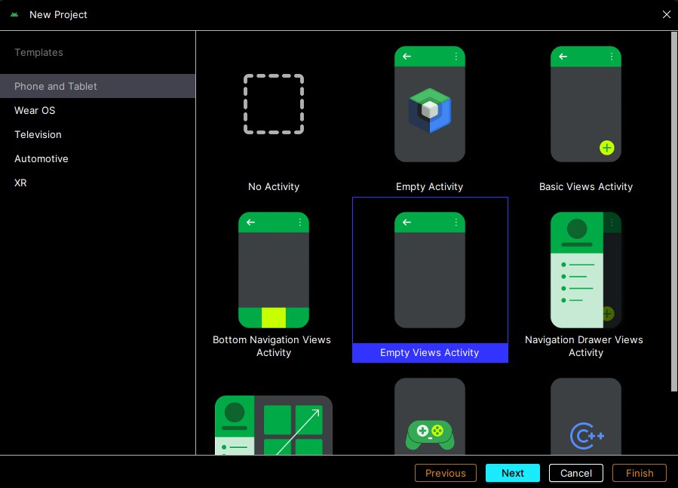
Create a new project (empty views activity)

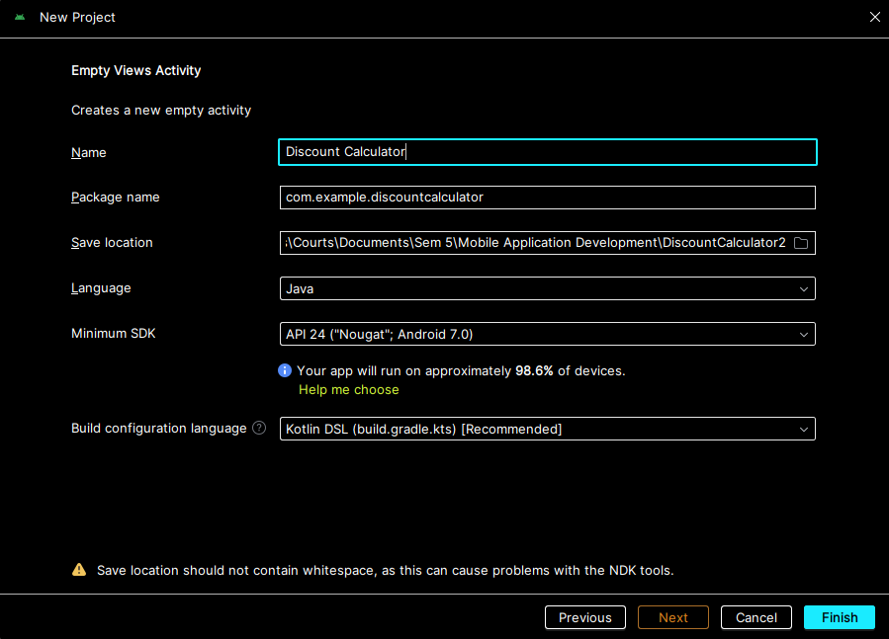
Name the file as “Discount Calculator”

Change the view of interface layout to relative layout
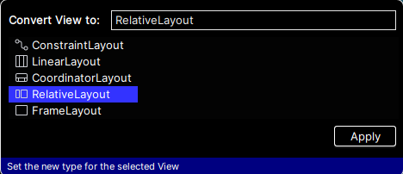

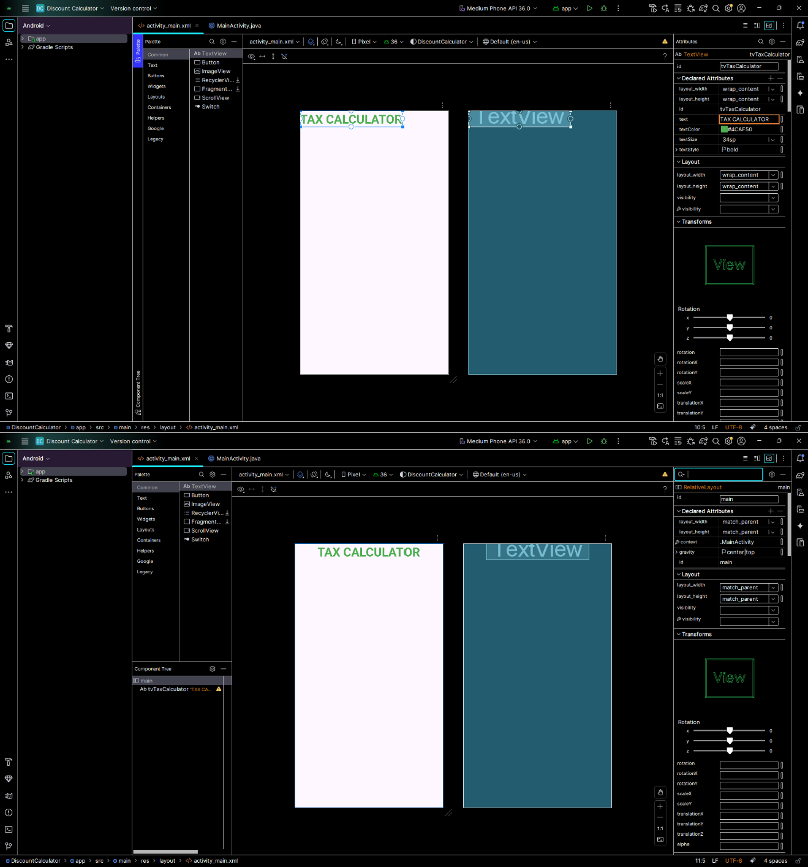
Add the textview (tax calculator) and set the attributes

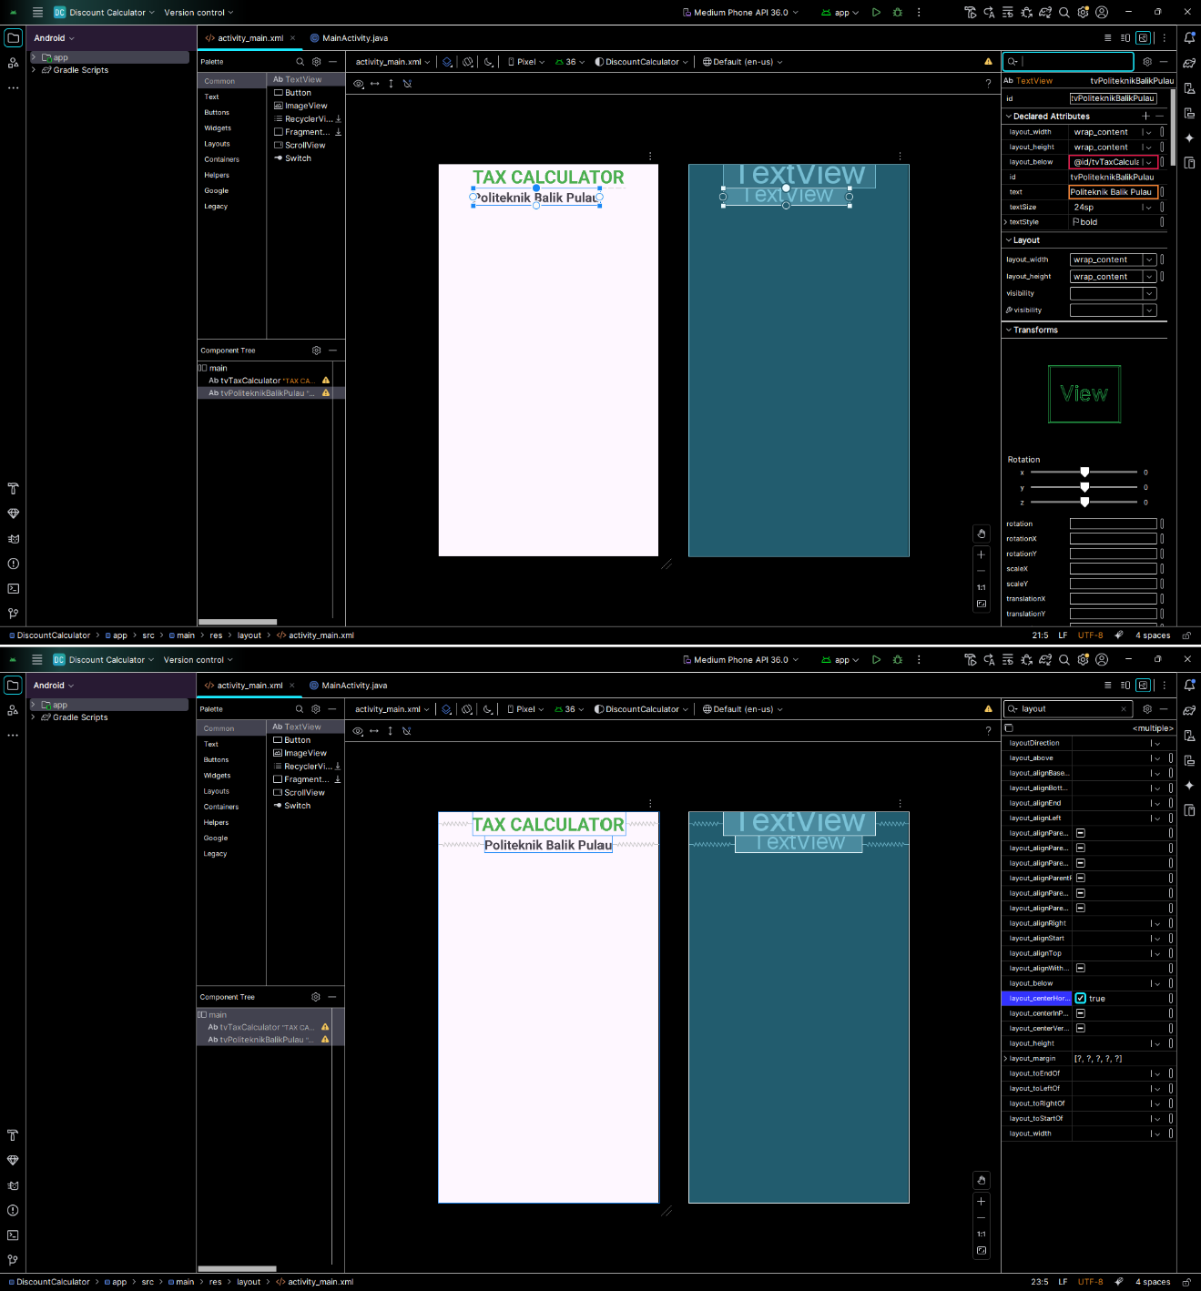
Add the second textview (Politeknik Balik Pulau) and set the attributes

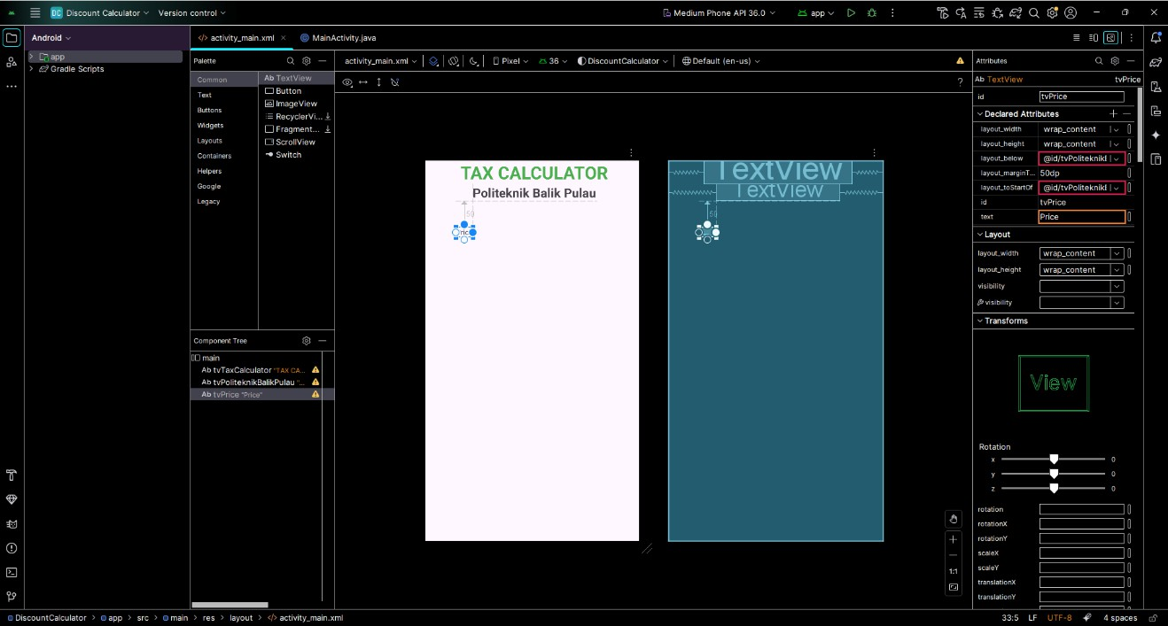
Add the third textview (Price) and set the attributes

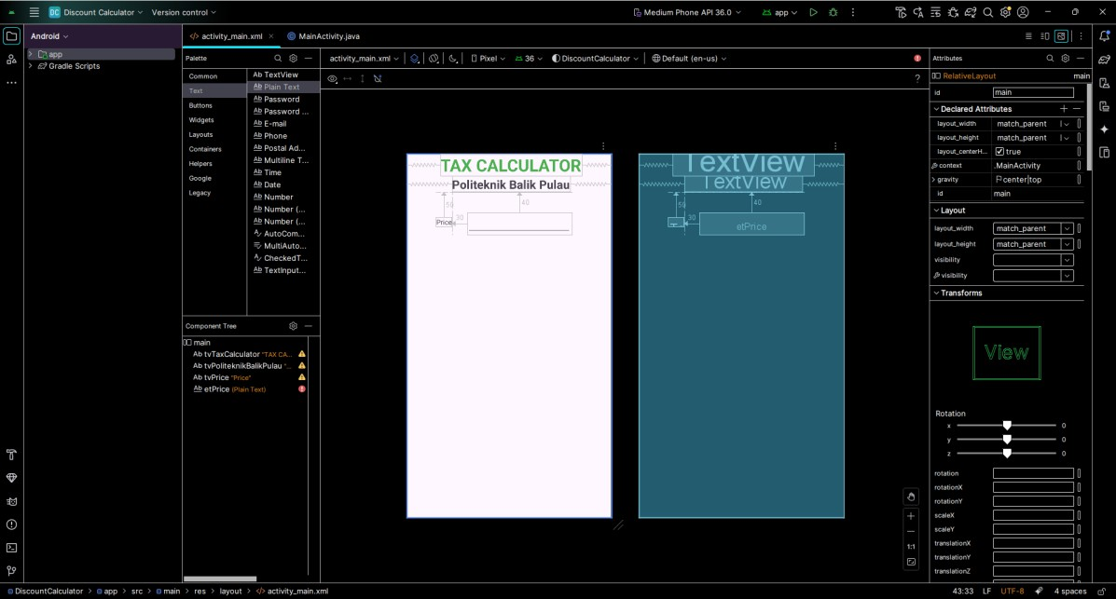
Add the plain text and set the attributes

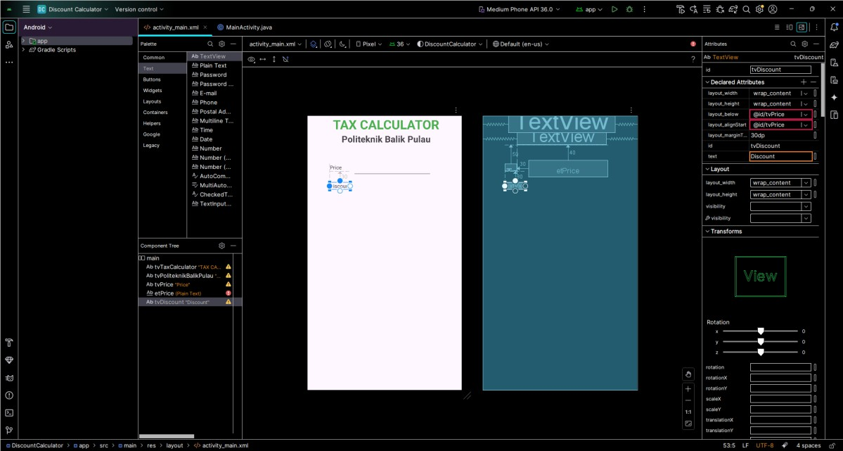
Add the fourth textview (discount) and set the attributes

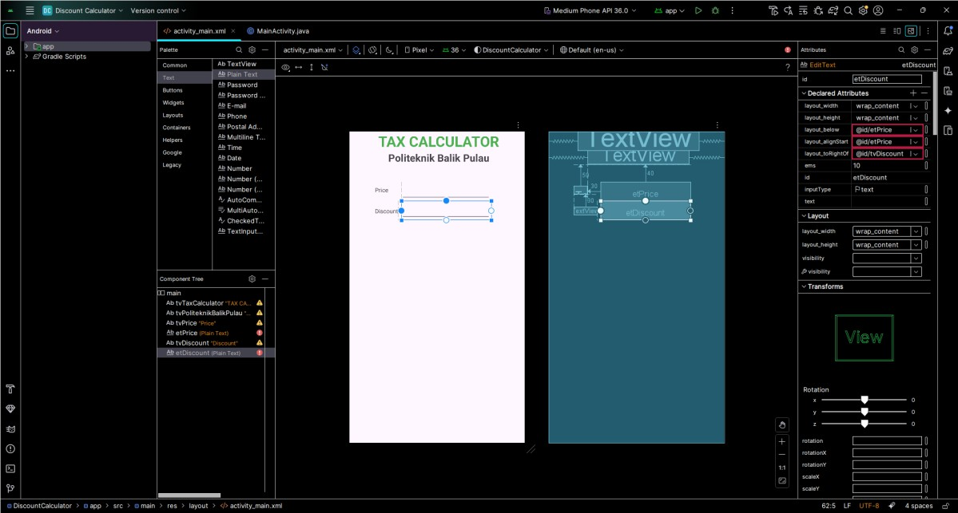
Add the second plain text and set the attributes

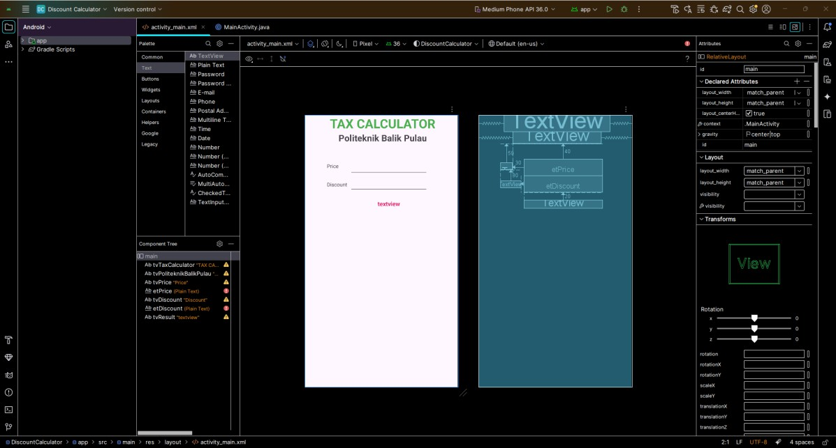
Add the fifth textview (textview) and set the attributes

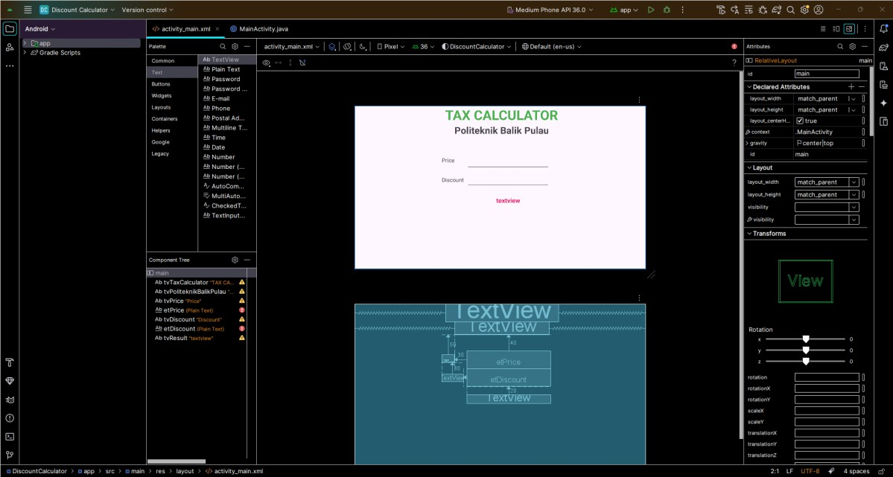
Change the layout from portrait to landscape

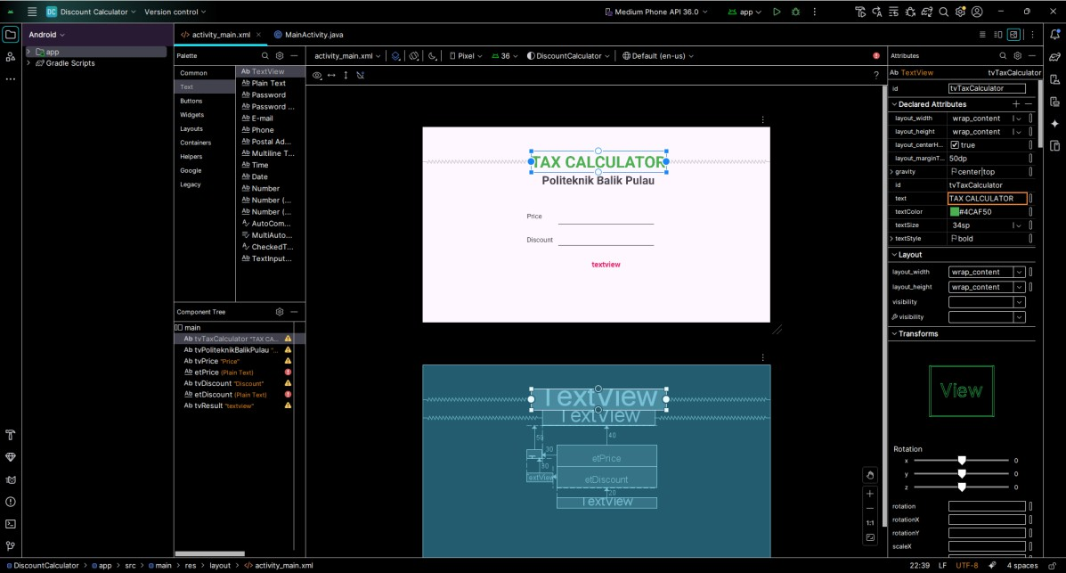
Adjust the margin top of tax calculator

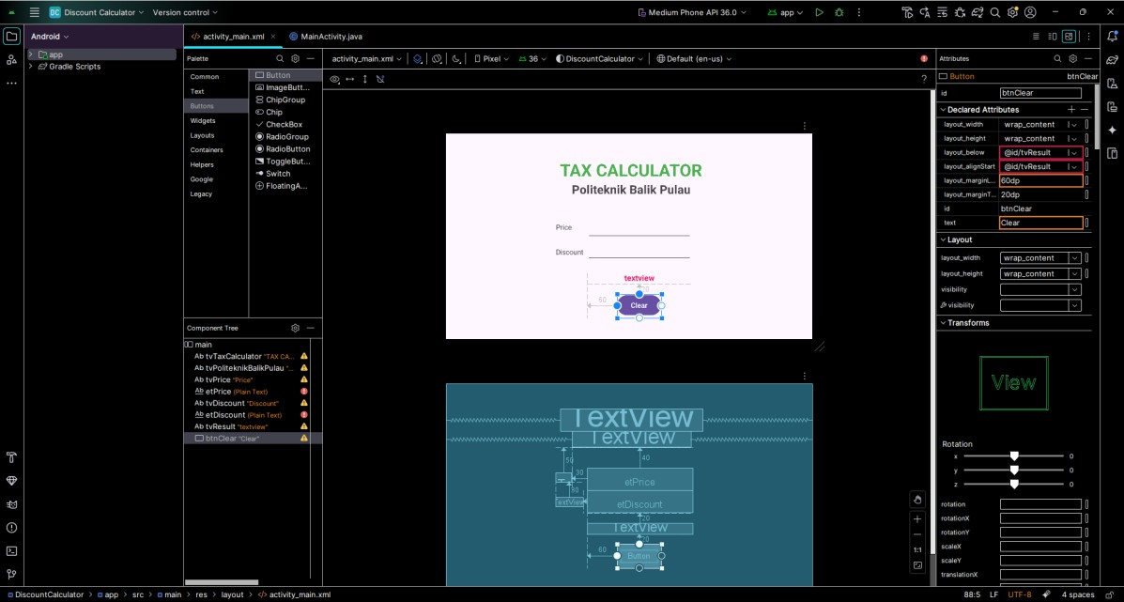
Add a button (Clear) and set the attributes

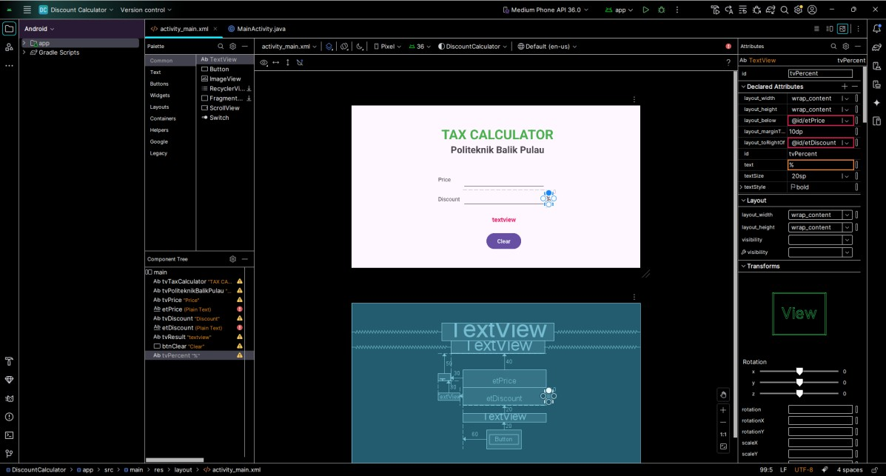
Add the sixth textview (%) and set the attributes

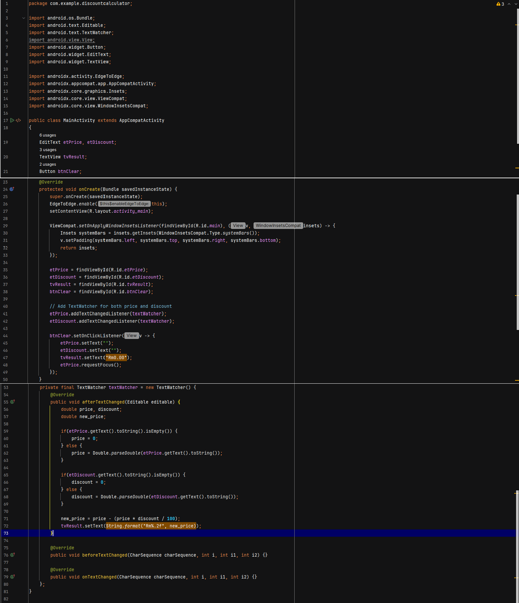
Apply the coding

The output
